**Lab-4 (Ionic)**

In this lab, we will be creating 3 Screen i.e.. Login, Registration, Main Screen.

In Main Screen we will have mashup of 2 web services and we will use Yslow to analyze the performance and a Camera Plugin which our team-2 will be using in our Project.

1. ***Login and Registration Screens:***

Login and Registration Screens are developed using Ionic.

Created a Project:

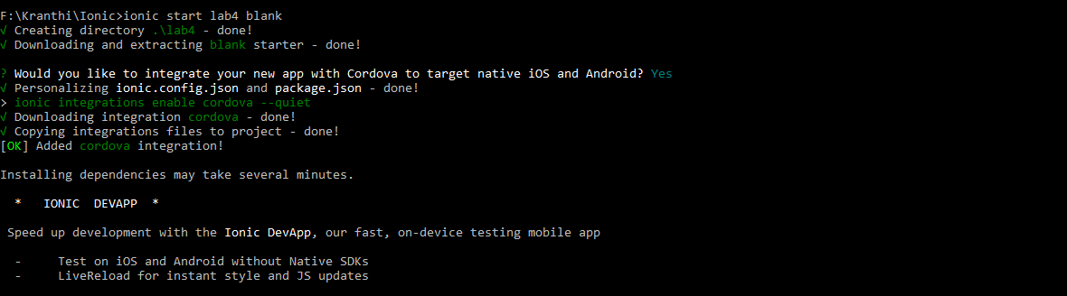

1. ***Created Login, Register Pages using Below commands:***

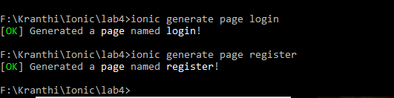

1. ***Into Configuration:***

As we have created 2 new pages, and we should have LoginPage as root page, so made below change in “app.component.ts” to do that,

**rootPage**:**any** = LoginPage;

Then, we will be using these pages in “app.module.ts”:

**declarations**: [  
 MyApp,  
 LoginPage,  
 RegisterPage,

**entryComponents**: [  
 MyApp,  
 LoginPage,  
 RegisterPage,

That’s all for the configuration.

1. ***Into Coding:***

Created a Login UI which will look like below:

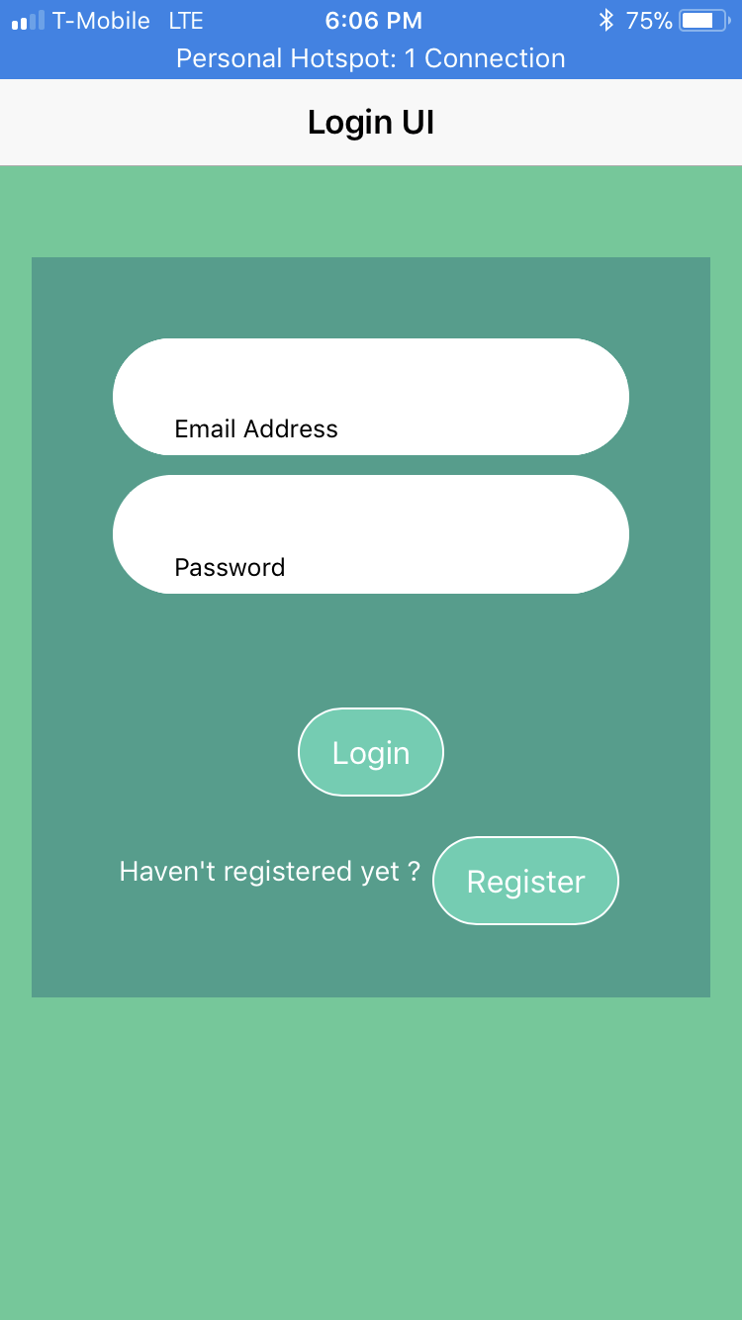

**Html Code Snippet:**

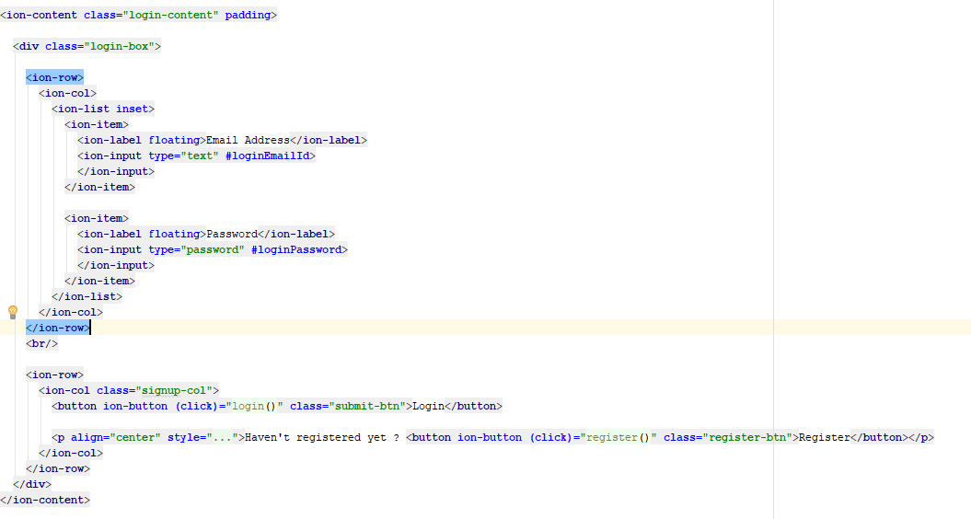

Created 2 Textbox fields, and 2 button fields using above code.

**CSS used:**

Css is added for the ionic elements to make UI look good.

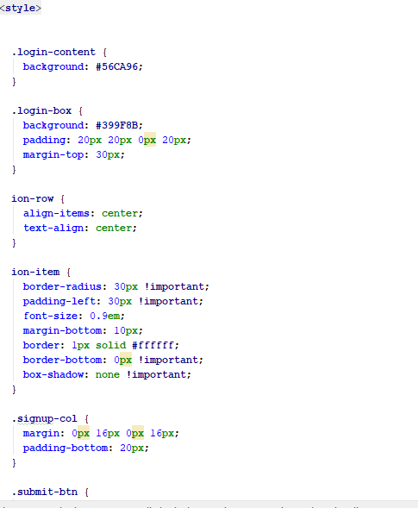

**Type Script Code on Login Click:**

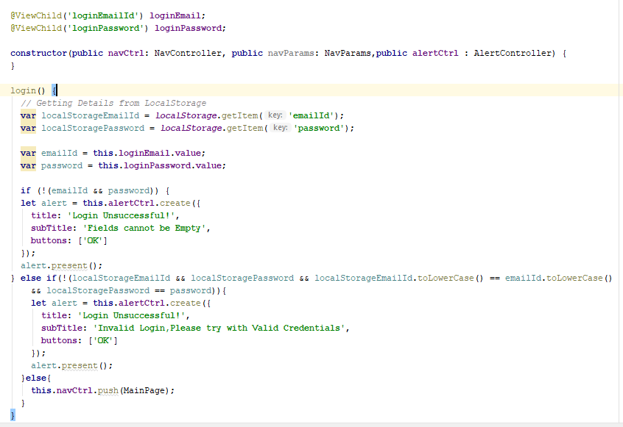

First, we will be importing “ViewChild” like below:

**import** { Component,ViewChild } **from '@angular/core'**;

Using this, we will be fetching the text field values from Login UI and use those fields for Validation.

First, we will be checking if fields are empty and throw an alert if not empty.

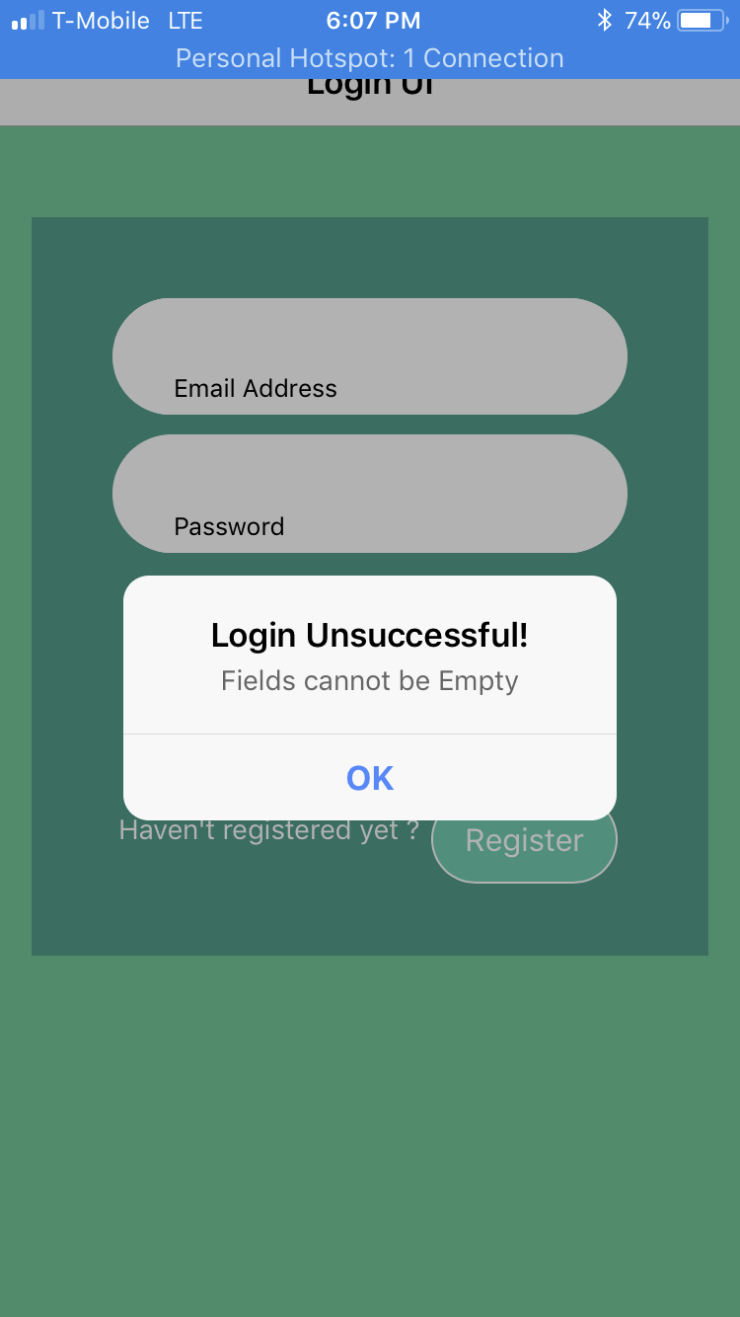

If Invalid Credentials are given, again we will be giving an Alert saying Invalid Login:

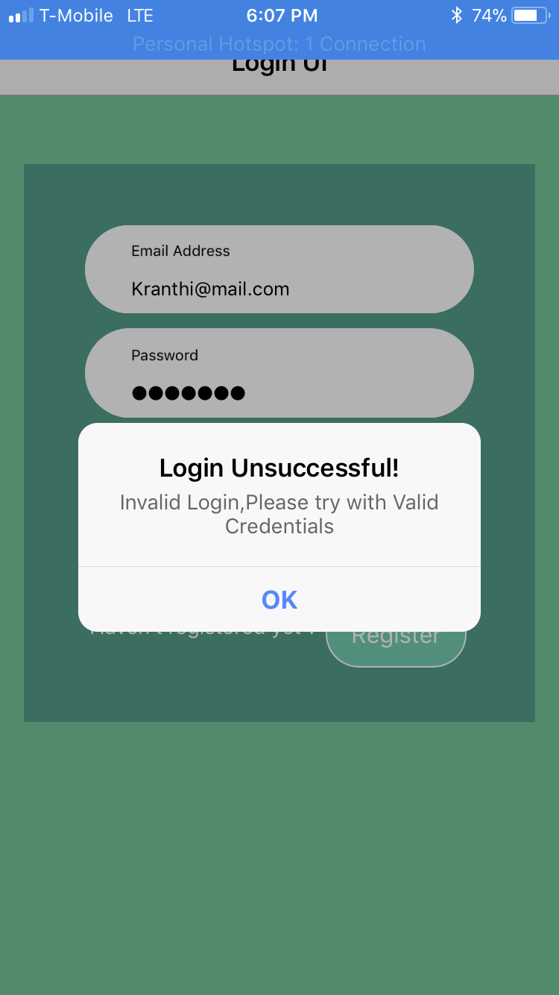

**On Register Button Click:**

register(){  
 **this**.**navCtrl**.push(RegisterPage);  
}

We will be navigating to RegisterPage which will look like below:

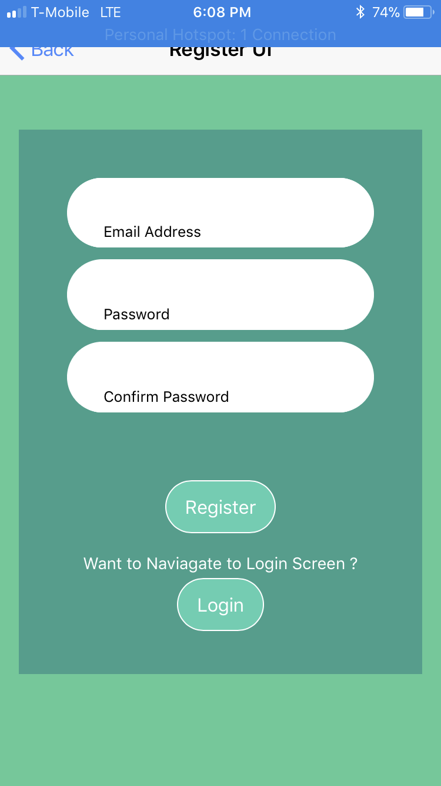

Same CSS which are used in Login Page are re-used here as well.

As used above, we will be Importing ViewChild and using those we will be fetching the textbox fields of Register Page.

**Html Code Snippet:**

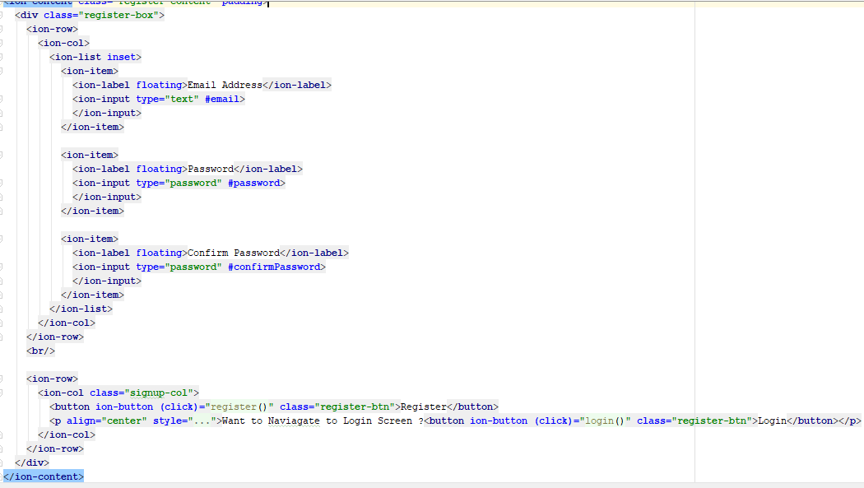

**Type Script Code:**

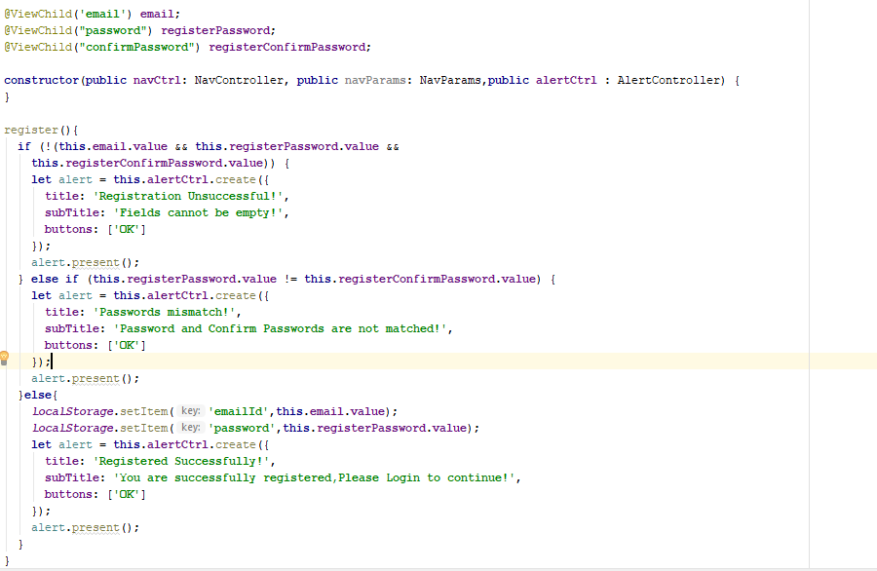

**Validations:**

Fields Empty 🡪 Check if all the fields are empty or Not.

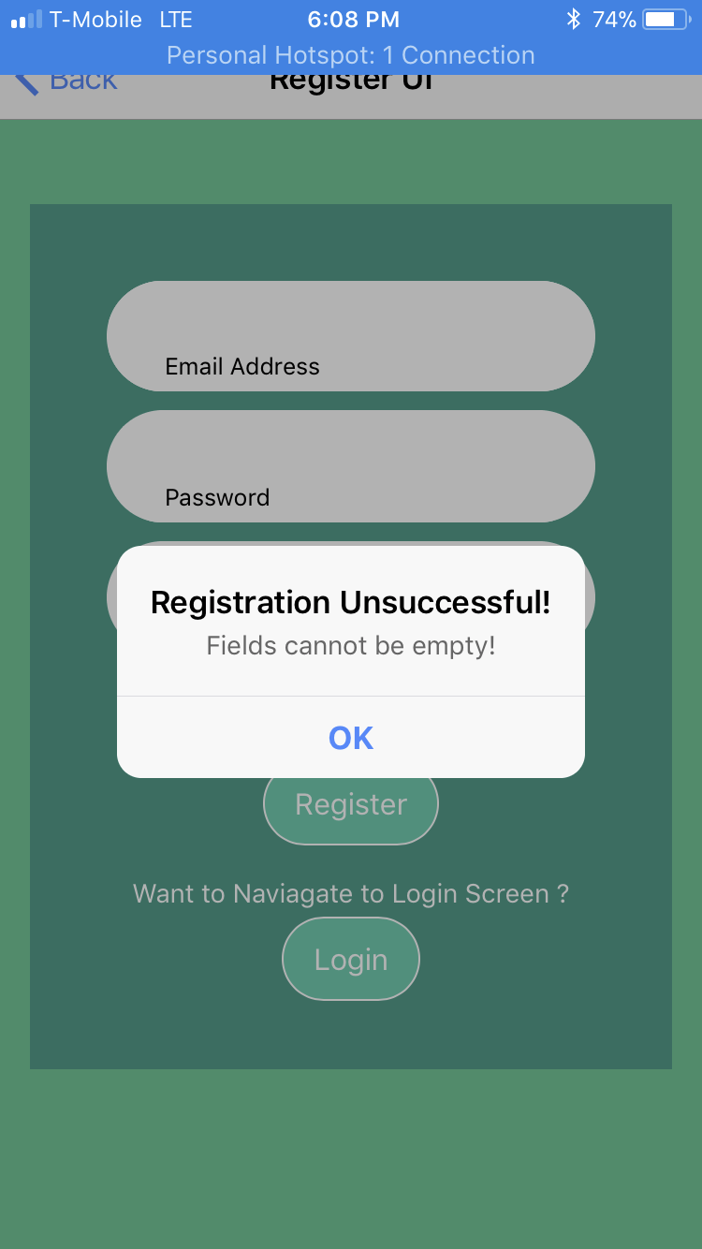

**Passwords Mismatch:** If there is a mismatch between password and Confirm Password.

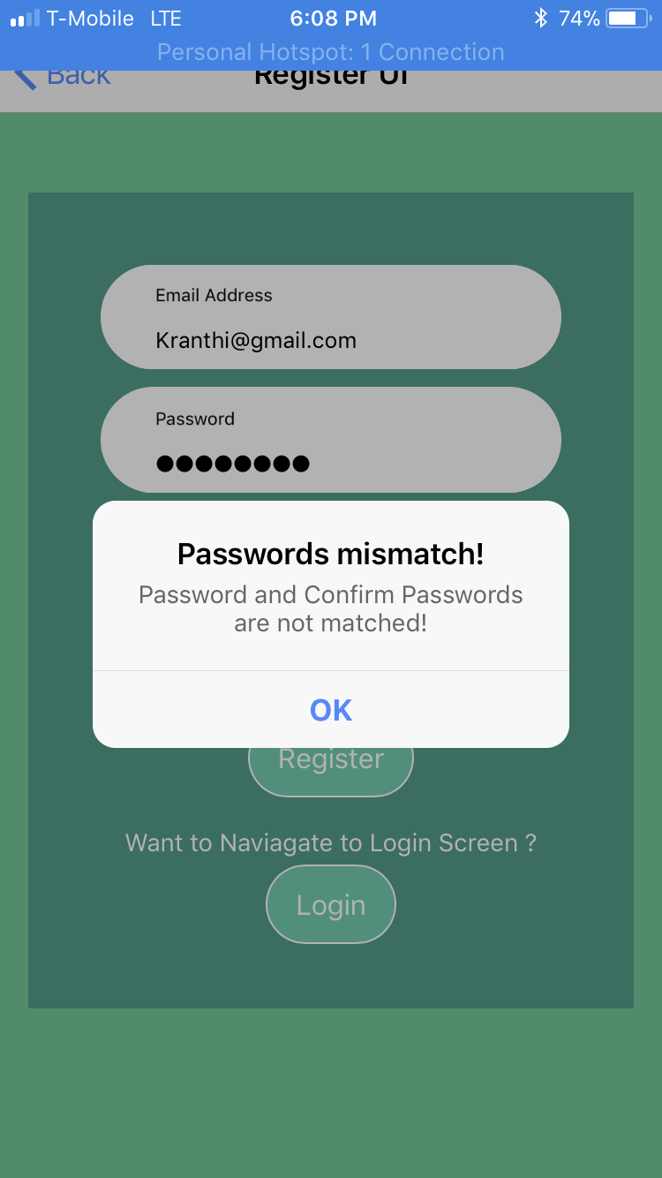

**Successful Registration 🡪** We will be using LocalStorage to set the Items of ‘emailId’ and ‘password’ and a Alert is given on Successful Registration.

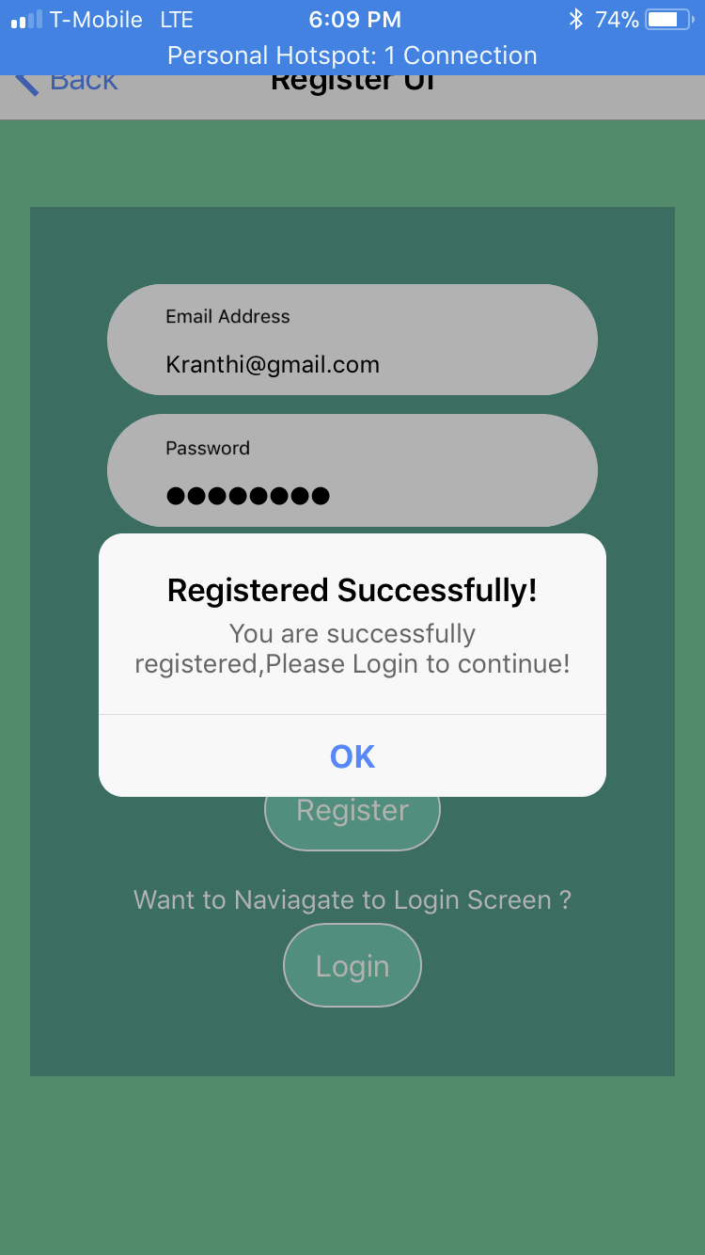

**Plugins**

Added Cordova Camera Plugin like below,

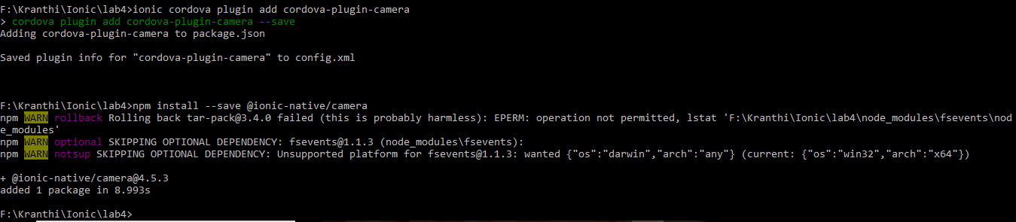

The Camera plugin will be used in our Project (Smart Shopping)

**Home Page**

Created a HomePage (MainPage) like below:

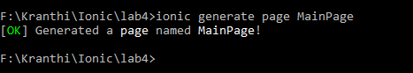

Now, we will be having two Services used.. where we gonna use Camera plugin to capture a Picture and use that picture to pass to Kairos API which will analyze and send us the Data.

& Using that data we will be using Google Translate API for text to Speech Conversion.

1. Registered for Kairos:

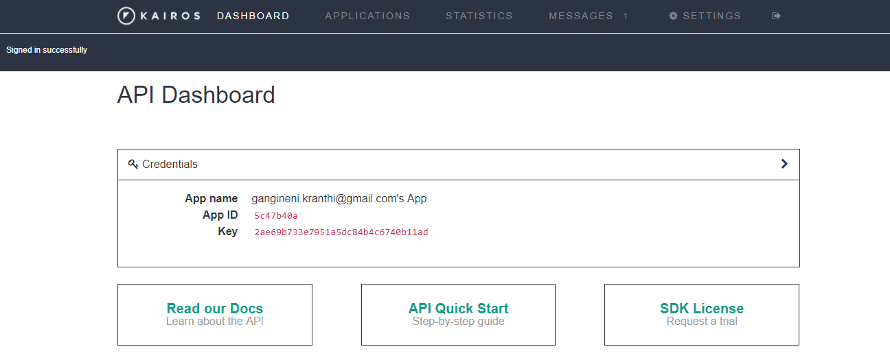

We will be using above API keys in our Ionic App.

Main UI:

As seen in Login Type Script, we will be validating if user passed Valid Login Credentials and If Successful MainPage will be displayed which will look like below:



On Click of ‘Take Picture’ button, we will be using Camera Plugin like below which we will be using to show Image on UI:

**Html Code Snippet:**

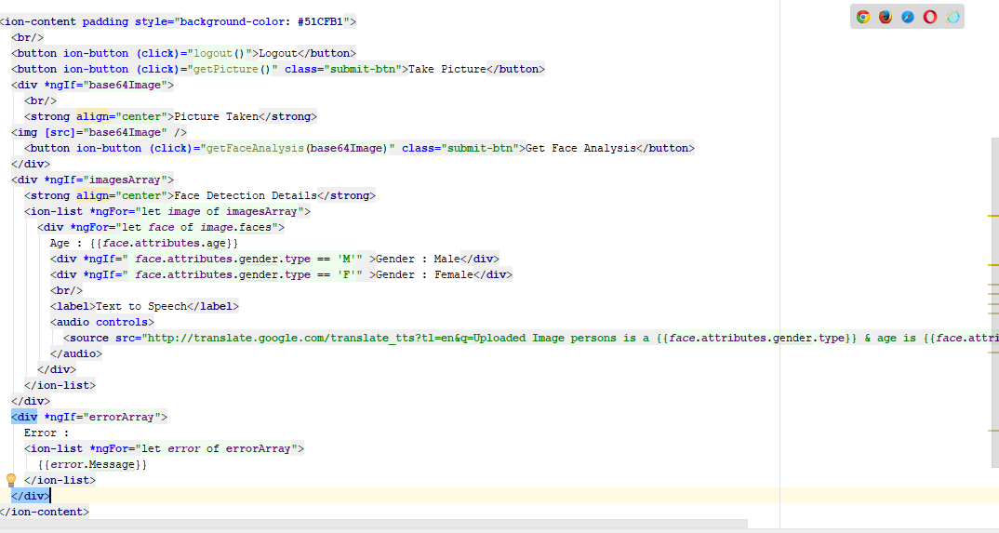

**Type Script Code:**

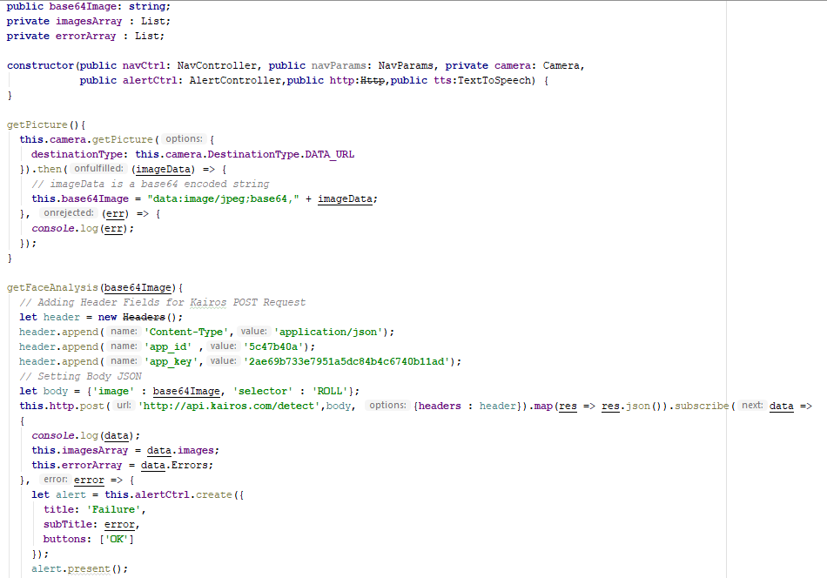

On Click of take picture we will be allowing User to take a Picture and will be stored as a base64Image and displayed in UI along with a Button ‘Get Face Anaysis’:

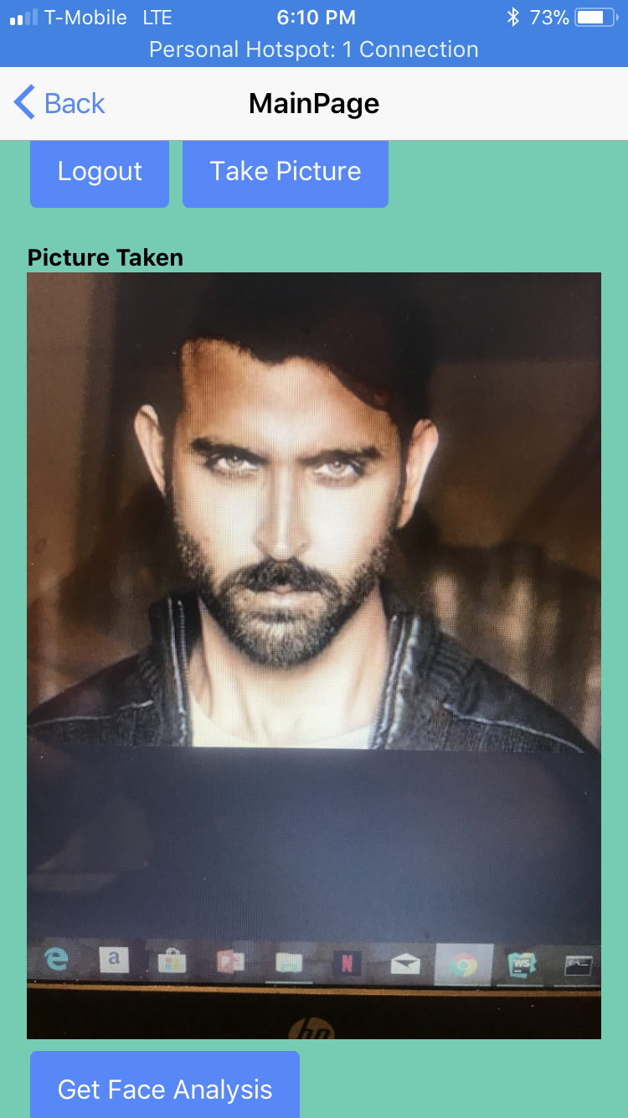

On Click of Face Analysis, Kairos Face API will be called like below,

getFaceAnalysis(base64Image){  
 *// Adding Header Fields for Kairos POST Request* **let** header = **new** Headers();  
 header.append(**'Content-Type'**,**'application/json'**);  
 header.append(**'app_id'** ,**'5c47b40a'**);  
 header.append(**'app_key'**,**'2ae69b733e7951a5dc84b4c6740b11ad'**);  
 *// Setting Body JSON* **let** body = {**'image'** : base64Image, **'selector'** : **'ROLL'**};  
 **this**.**http**.post(**'http://api.kairos.com/detect'**,body, {**headers** : header}).**map**(res => res.json()).subscribe(data =>  
 {  
 ***console***.log(data);  
 **this**.**imagesArray** = data.**images**;  
 **this**.**errorArray** = data.Errors;  
 }, error => {  
 **let** alert = **this**.**alertCtrl**.create({  
 **title**: **'Failure'**,  
 **subTitle**: error,  
 **buttons**: [**'OK'**]  
 });  
 alert.present();  
 ***console***.log(error);*// Error getting the data* });  
}

This is a POST request, so setting all the required headers, Body fields as said in Kairos documentation.

<https://kairos.docs.apiary.io/#reference/face-recognition/detect/post?console=1>

& Data will be sent to Html where we will iterating JSON to get the Required Fields for this Application i.e.. Age and Gender.

**Valid Face Detection:**

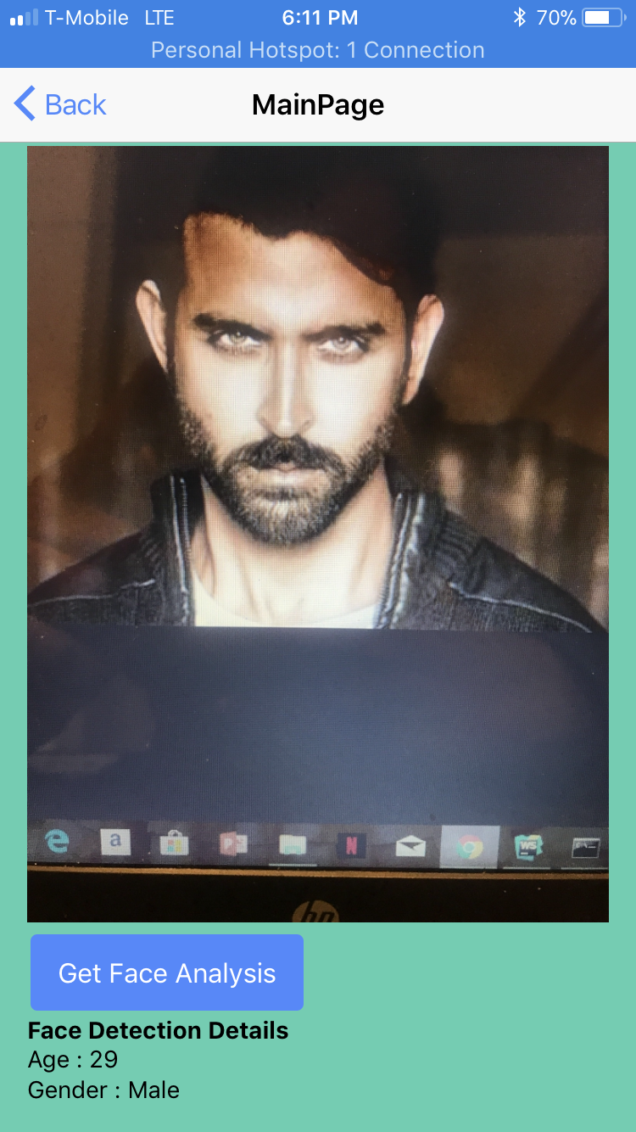

If No Faces Found 🡪

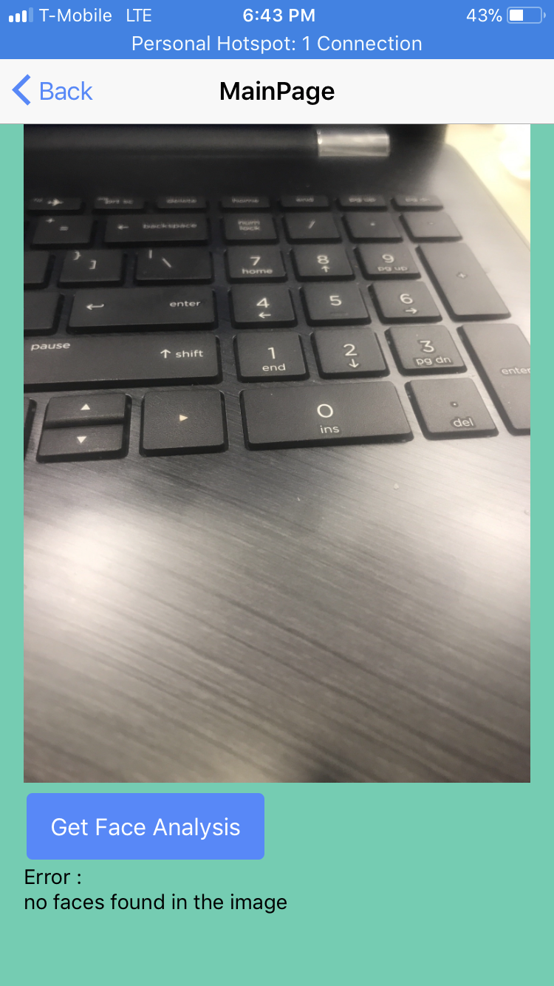

**Google Translate API:**

2nd Mashup service is Google Text to Speech API where we will be able to listen to the content of the Face Analysis done by Kairos.

<**audio controls**>  
 <**source src="http://translate.google.com/translate_tts?tl=en&q=Uploaded Image persons is a {{*face*.attributes.gender.type}} & age is {{*face*.attributes.age}}&client=tw-ob" type="audio/mp4"**>  
</**audio**>

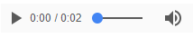

In UI, it will look like above.

**DEPLOYMENT**

Deployment is done into IOS using Ionic DevApp, All Form Screenshots above are in Ionic DevApp only.

**YSlow Performance**

Performance is analyzed using YSlow like below. First, added an Extension ‘Yslow’ in Chrome.

For Login Page 🡪

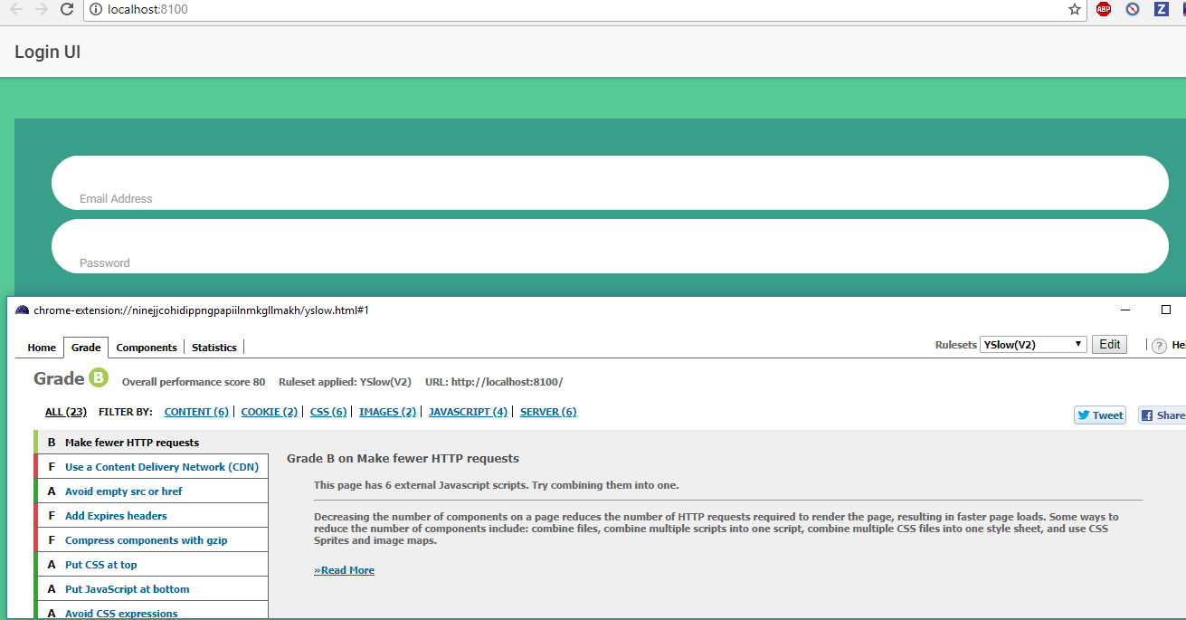

Yslow Registration 🡪

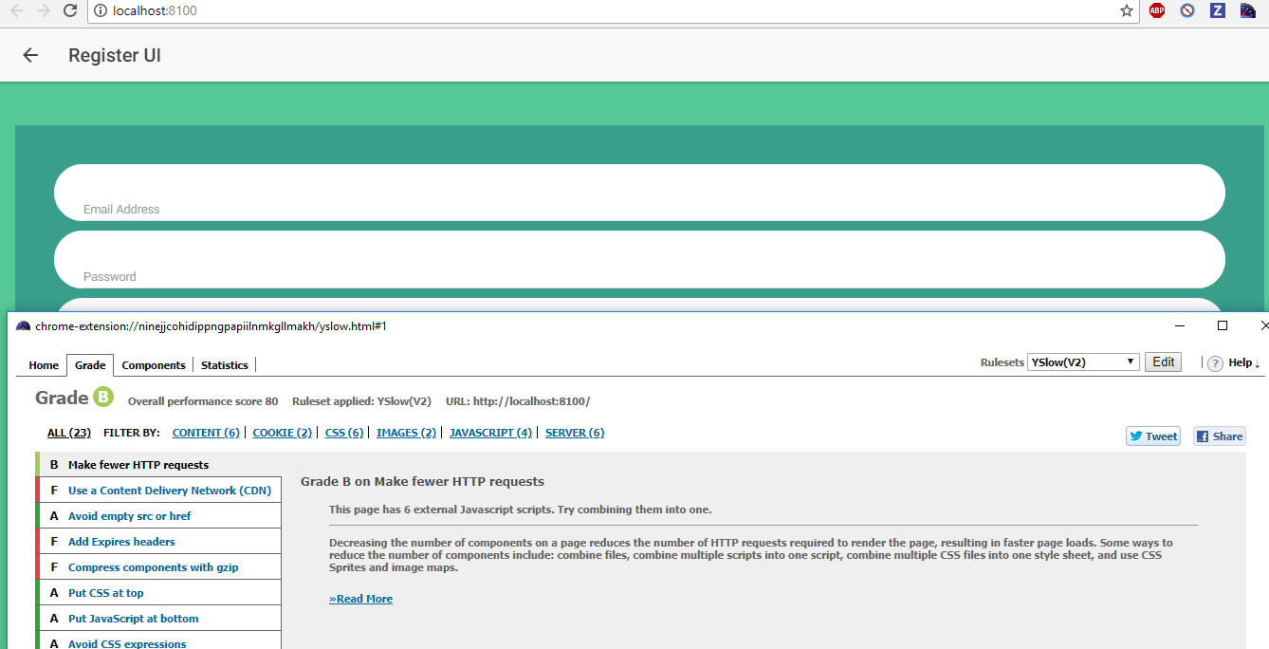

YSlow Main UI 🡪

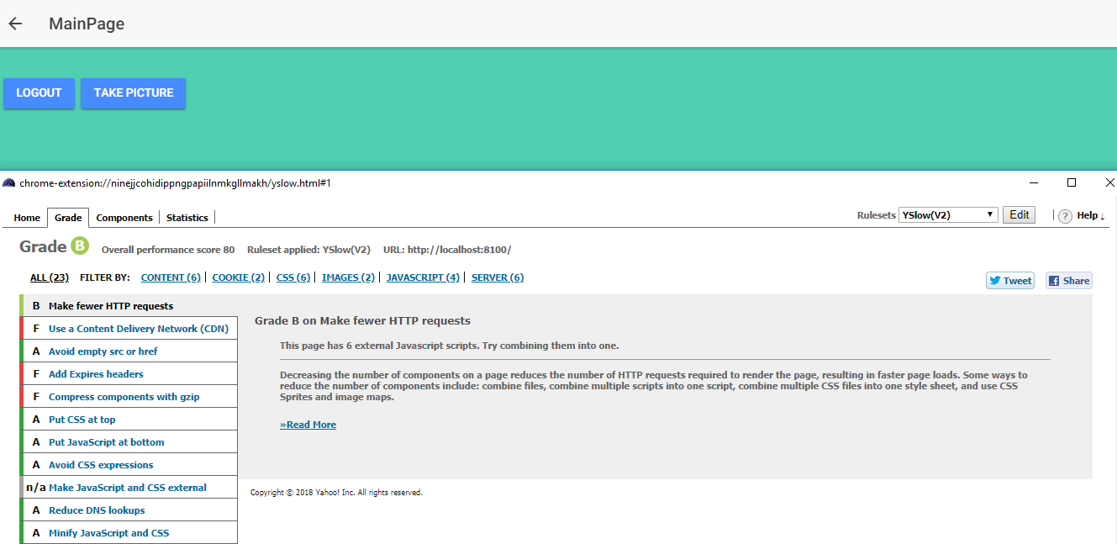

**TESTING**

3 Unit Test Cases are writer like below and ran using Karma Jasmine,

